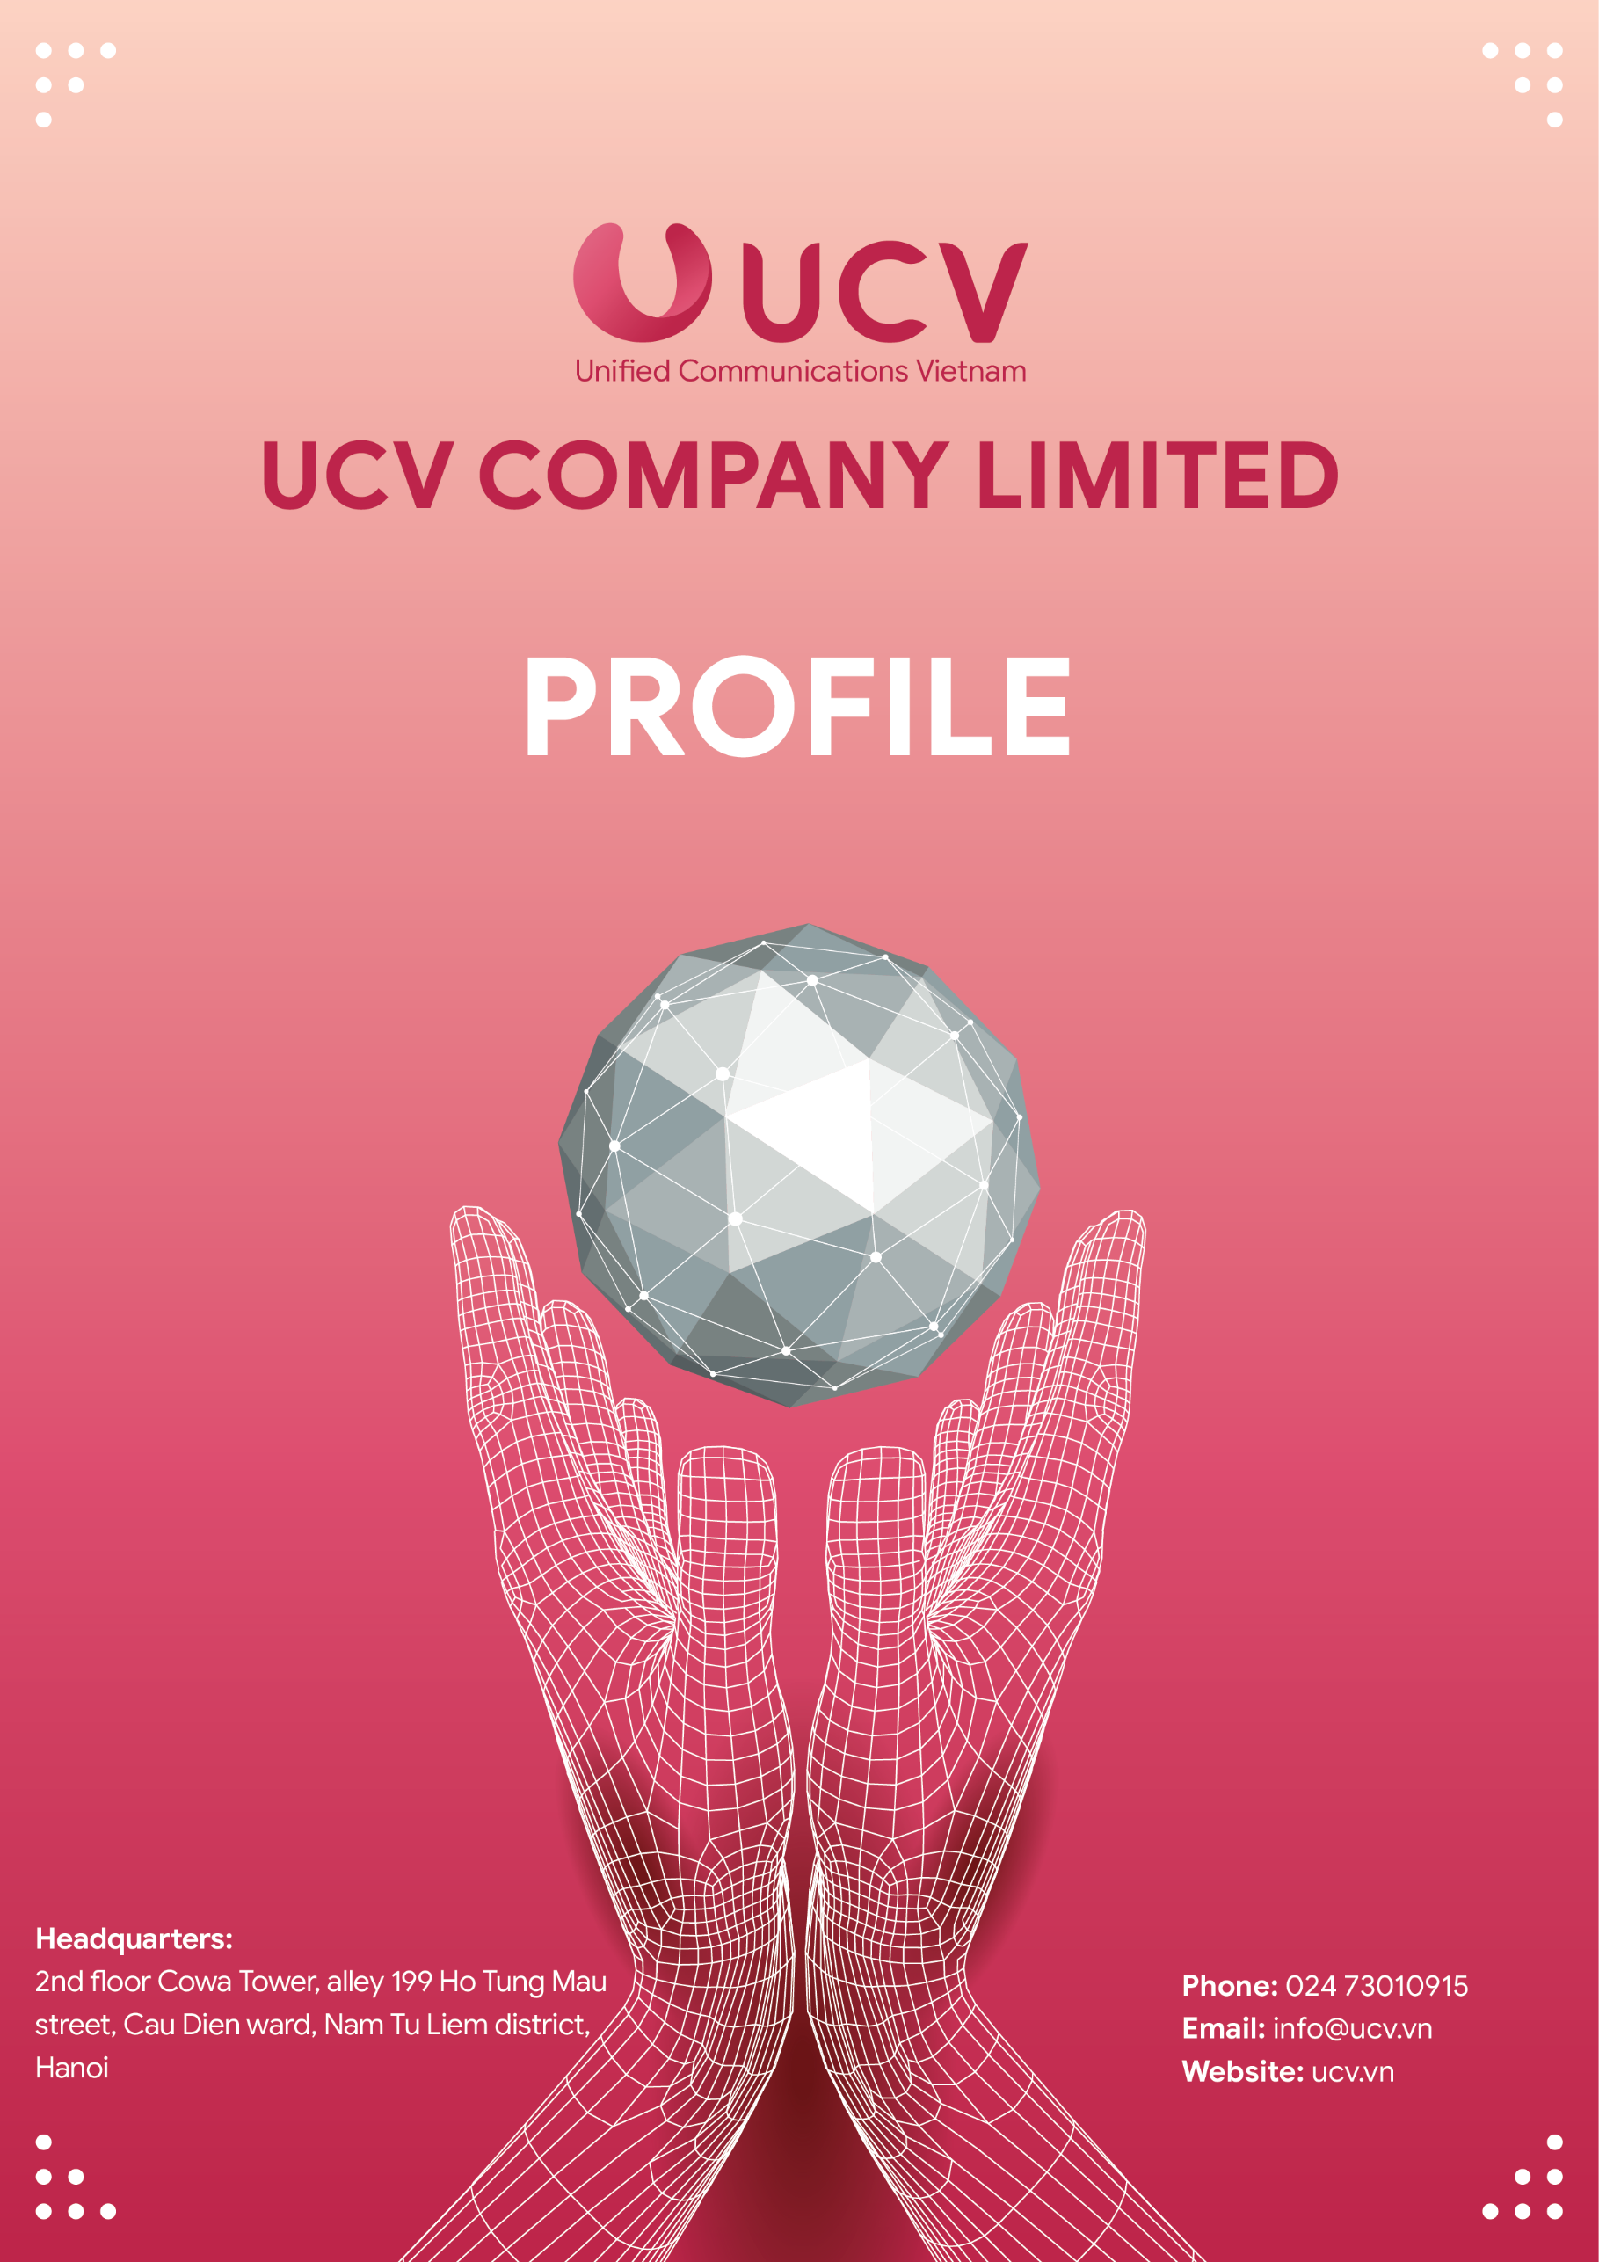

TABLE OF CONTENTS
OVERVIEW 3
BUSINESS AREAS 3
SERVICES, PRODUCTS & SOLUTIONS 4
Server & Data center services 4
Cloud computing-based services 5
Products – Information technology hardware equipment 6
Products – Copyrighted software products 6
Information technology and telecommunications infrastructure solutions 8
PERSONNEL 10
CUSTOMERS 11
MANUFACTURERS & FIRMS 12
THANK YOU 12

OVERVIEW

BUSINESS AREAS
UCV is Vietnam’s top provider of services, products, and well-rounded technology solutions which help companies build IT systems, optimize management and business, accelerate digitization and digital transformation to keep pace with The Industrial Revolution 4.0.

SERVICES, PRODUCTS & SOLUTIONS

Server & Data center services
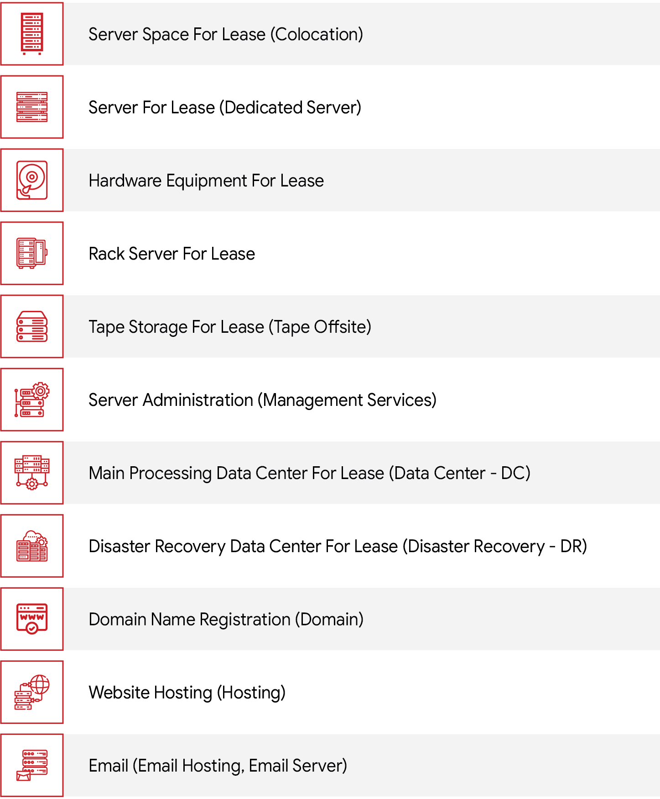

Cloud computing-based services
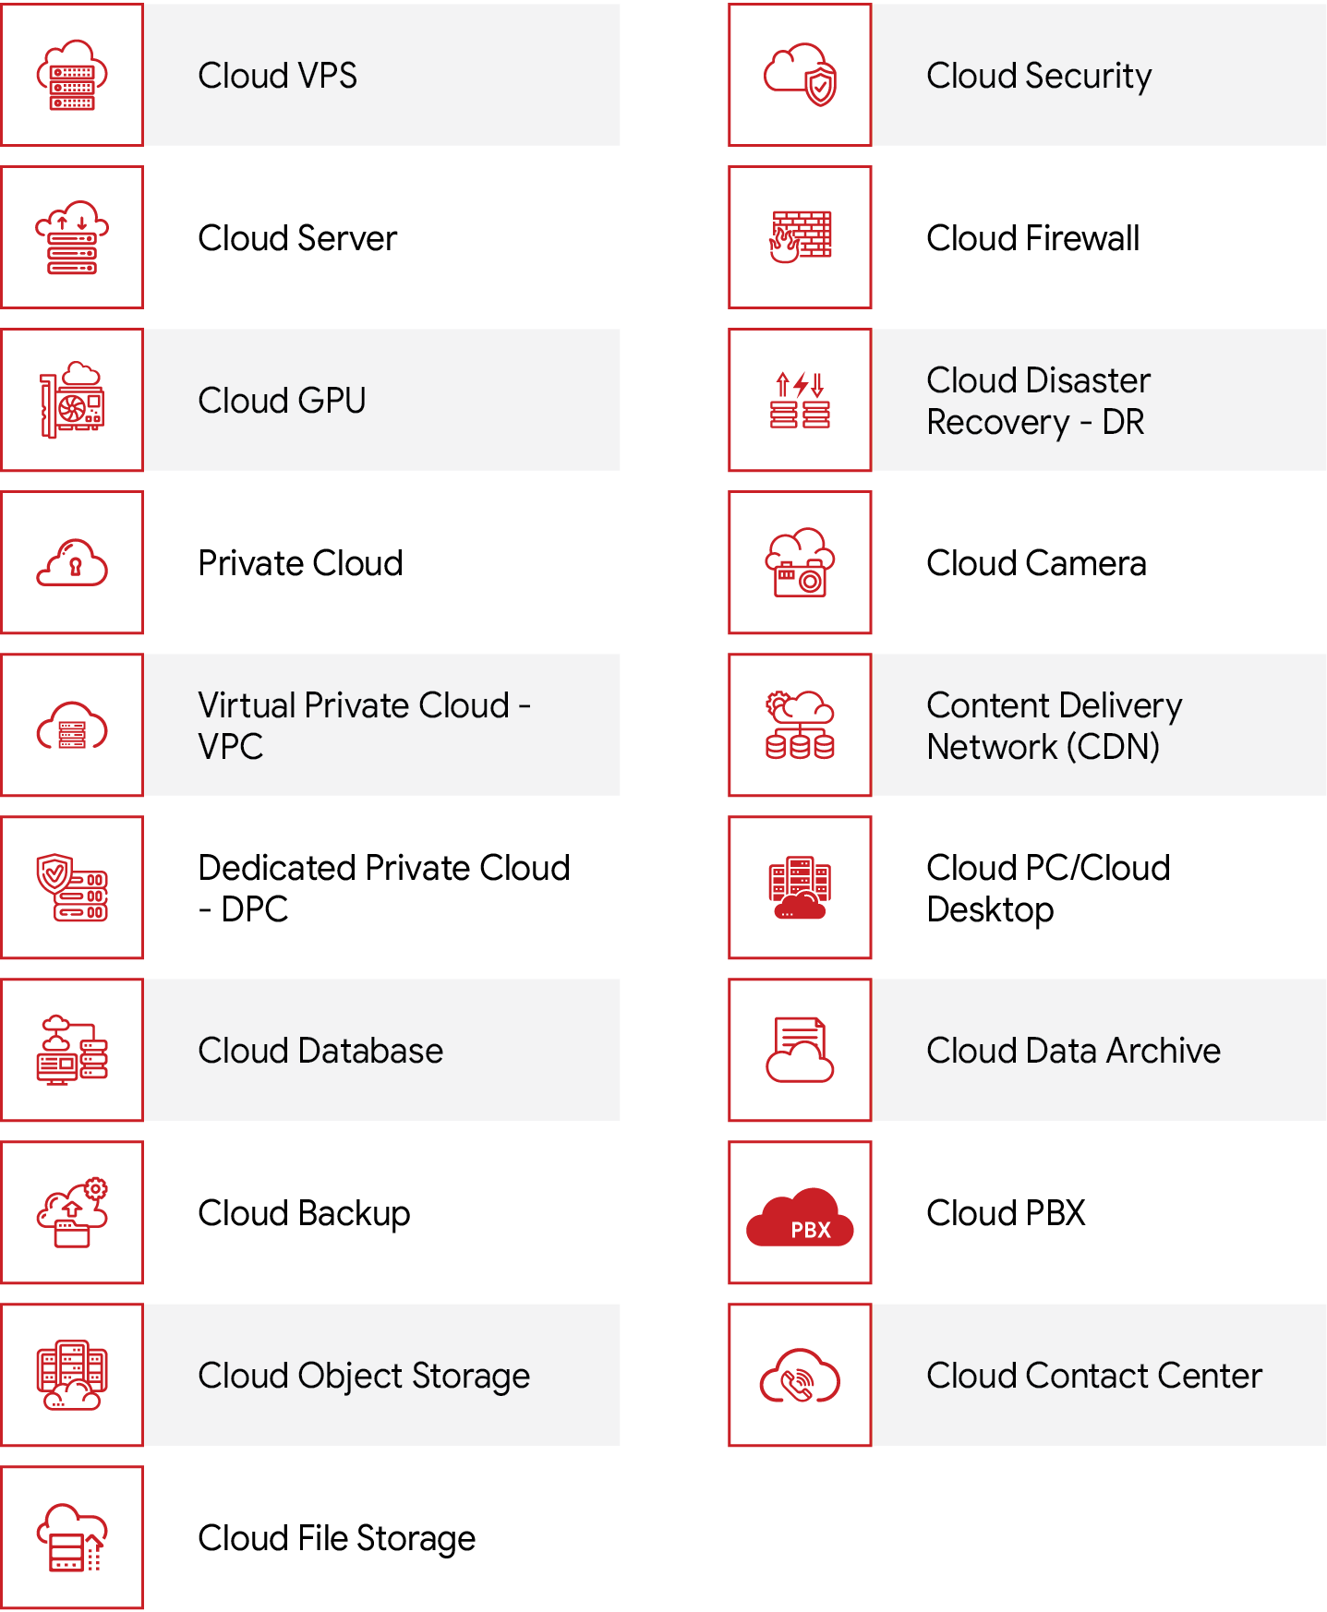

Products – Information technology hardware equipment
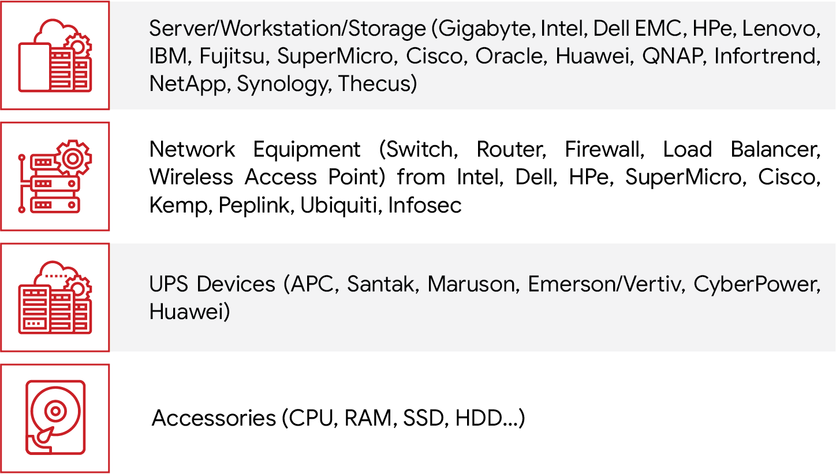

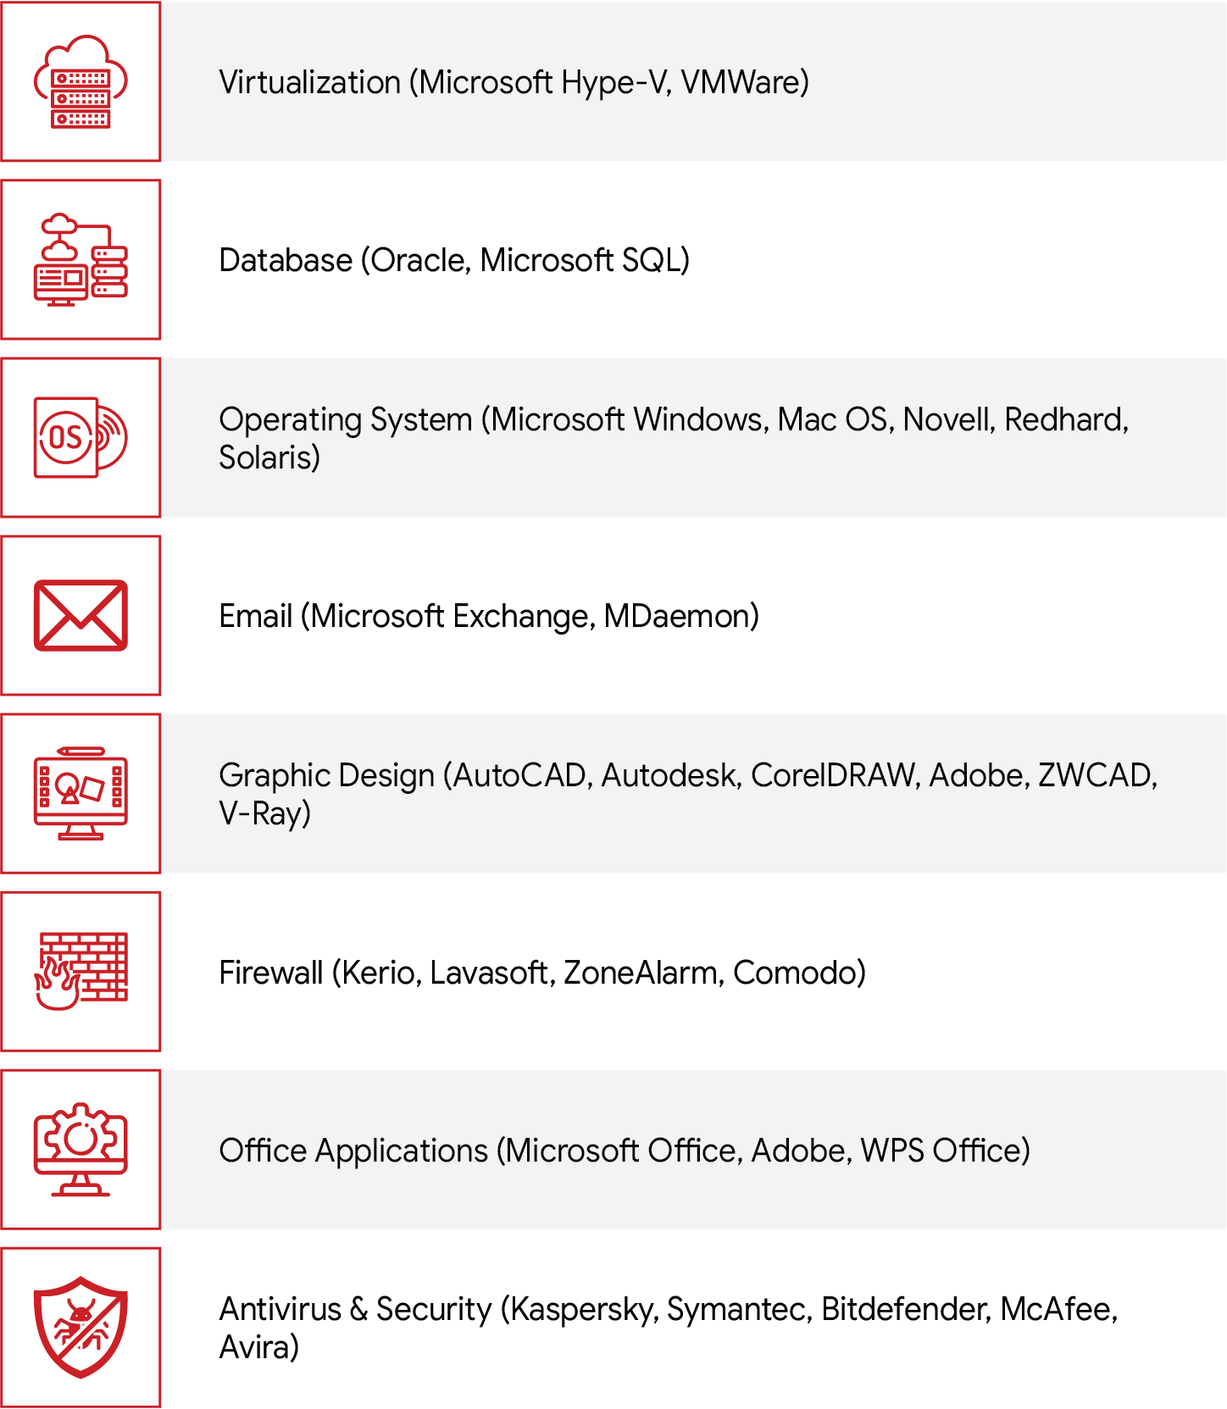
Products – Copyrighted software products

Information technology and telecommunications infrastructure solutions
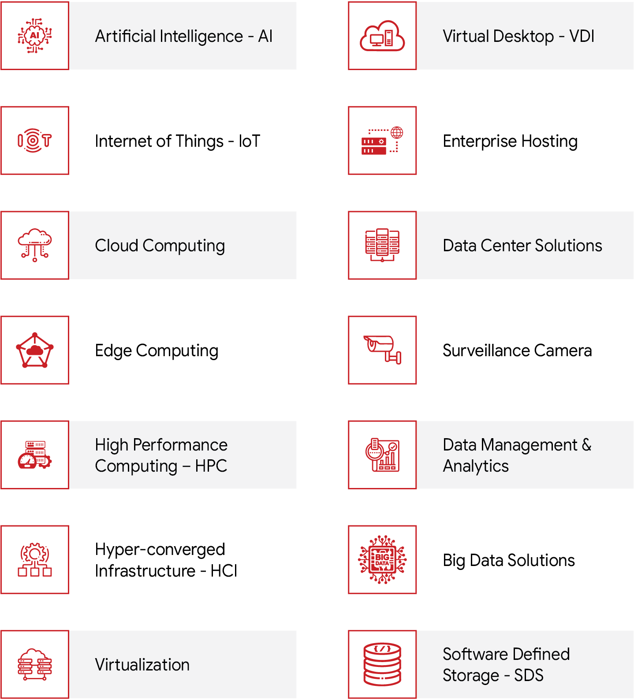

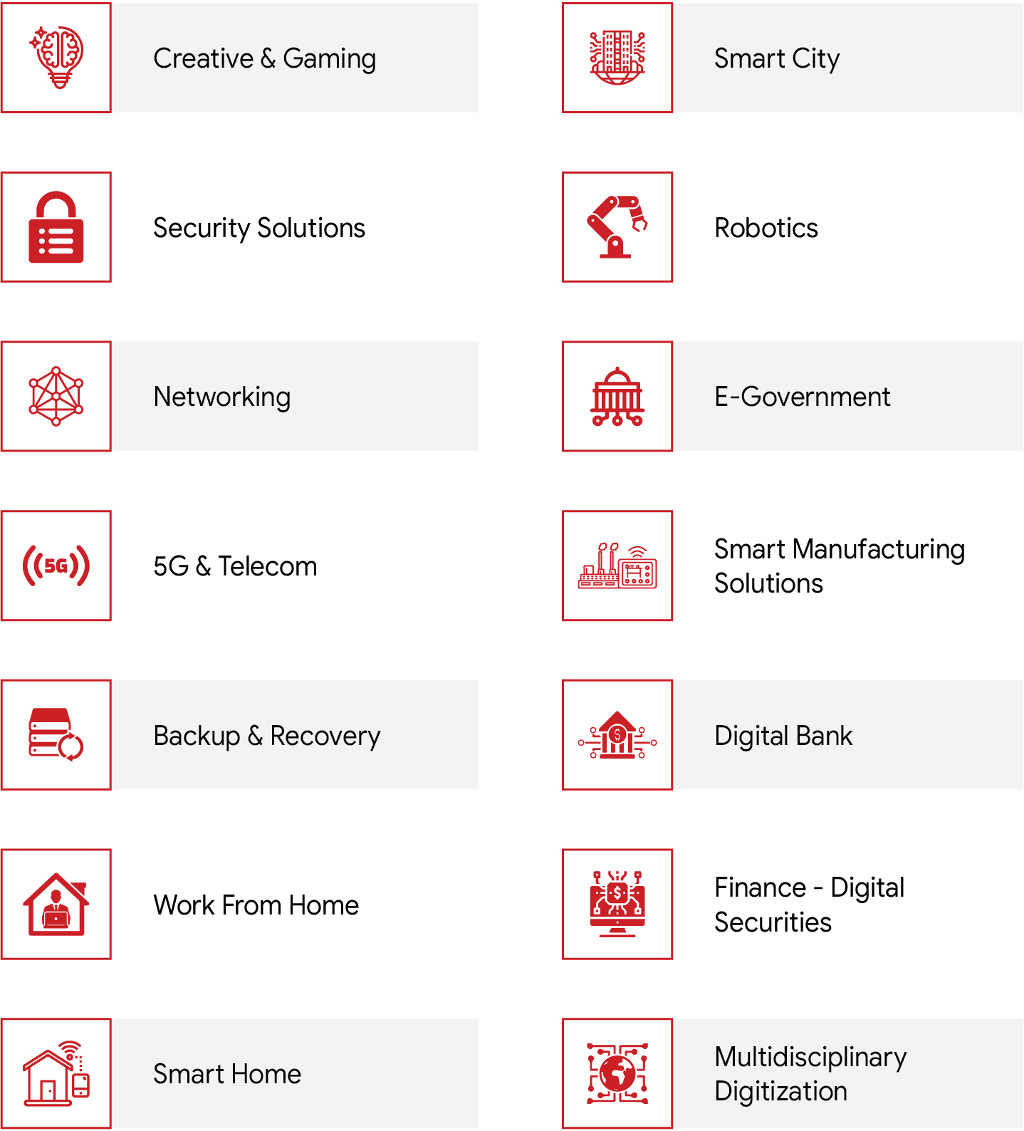

PERSONNEL
50+ IT and Telecommunications Specialists
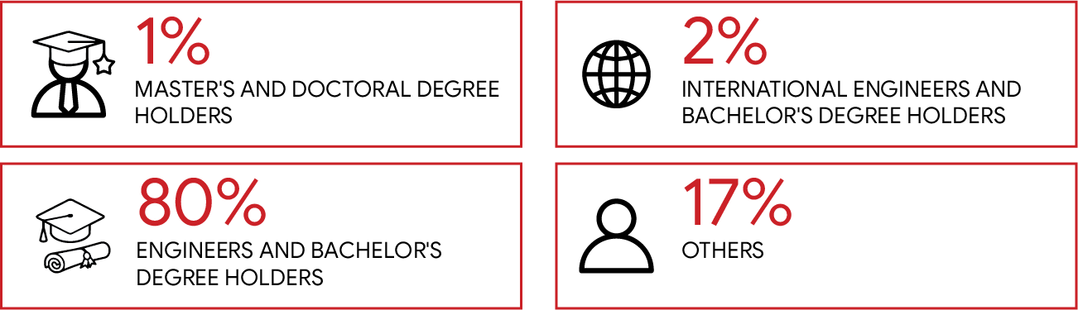


CUSTOMERS
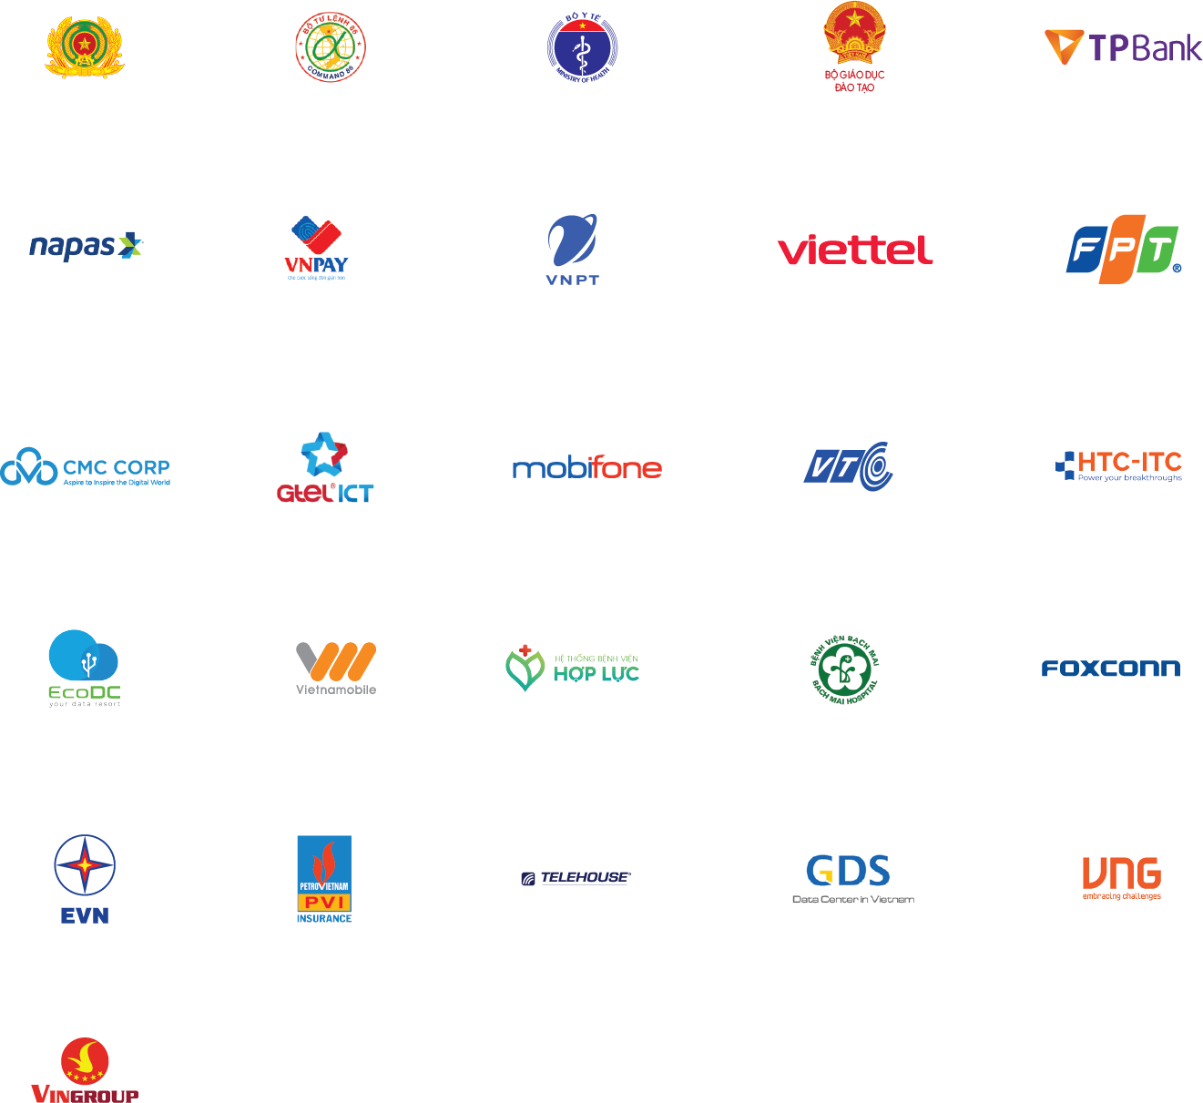

MANUFACTURERS & FIRMS
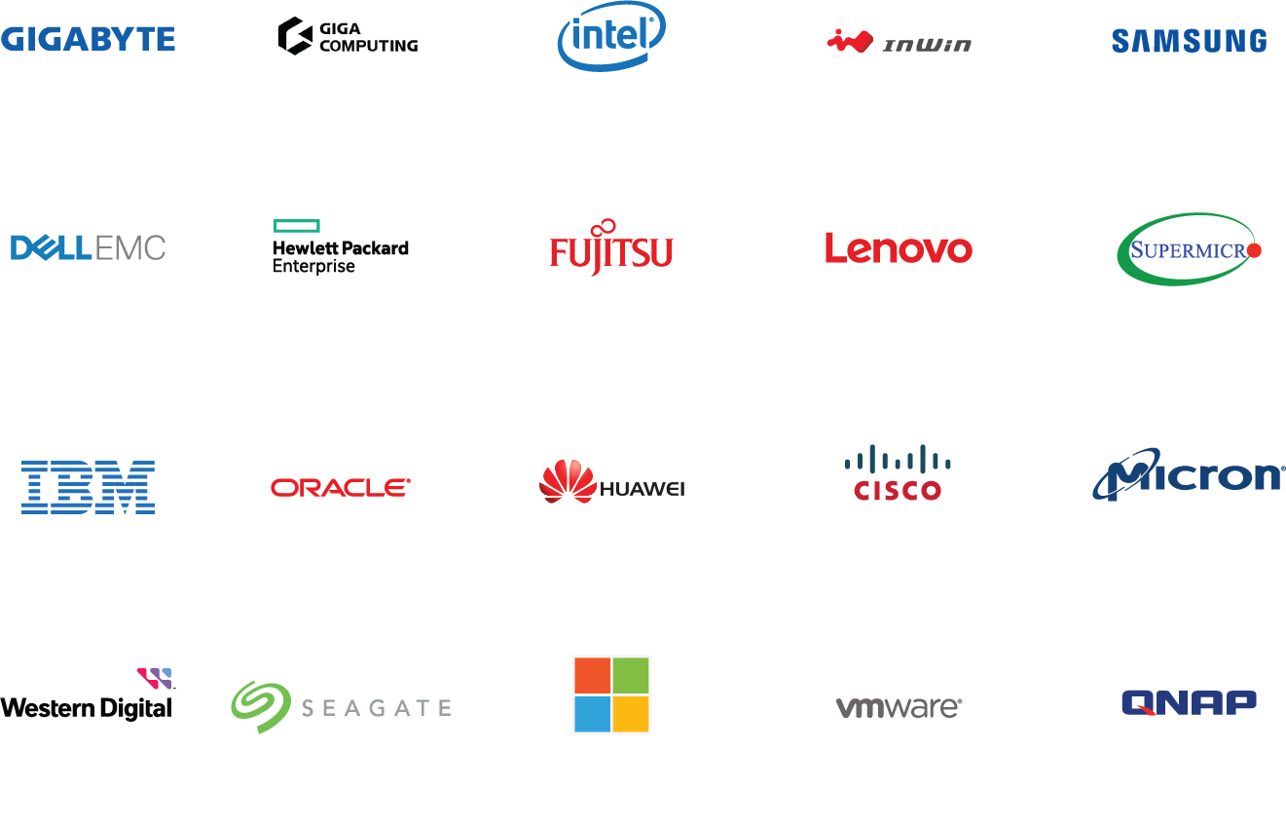

THANK YOU

